**A message from the Headteacher:**

Welcome Back!!

I hope you are all well and I would like to extend a warm welcome to the Hope View School community to our new pupils and their parents and carers.

12 pupils moved onto their college placements this term as their time at Hope View School came to end. They all achieved very highly in their final exams which has provided a platform for their next steps in education or training. You can find the 2023 summer exam results on our website by clicking the Curriculum tab. 12 new pupils joined the Hope View School community this term and they have already made a positive impact into their education at HVS.

Pupils have made a positive start to the academic year and their transitions from Lower to Upper or into new classes have been seamless. This is credit to the boy's resilience, positivity to change and determination to succeed. It has been a privilege to have already observed excellent work in the classroom with good progress being demonstrated.

At the start of week 4 of this half term I received a phone call from Ofsted to inform me of their intention to inspect HVS for the forthcoming 3 days. Pupils and staff really shone a positive light on the school and the inspectors commented favourably about their observations during the inspection. I am awaiting Ofsted to send me a copy of their report which I will publish on the website and email you a link as soon as I receive it, which can be at least 6 weeks from the end of the inspection. Thank you again for completing the Parent View Survey.

I hope you enjoy this edition of the newsletter which highlights many of the activities and events which have taken place so far this term.

**Hope View School**

**Autumn Newsletter**

Thursday 19th October



**Miss Hannah** would like to say a huge thank you to parents and carers who attended the **Macmillian Coffee Afternoon** – we raised a fantastic £132! Thank you for your generosity.

to improved exam performance which should in turn lead to further learning opportunities and better job prospects. As well as this, going to school helps to develop: Friendships, Social Skills, Team Values and Career Pathways. Please contact the office if your child is absent.

School is directly linked

**Good attendance** at school is not just valuable, it’s essential. Attending

friendships

social skills

team values

life skills

cultural awareness

career pathways

**Subject Focus – Science** Our focus in science is to link our observations to scientific explanations, so we have completed many practical activities to support our learning. In KS2 we have looked at materials and their properties and how electricity works, at KS3 we have looked at particles and how can they react, at KS4 we have observed different types of cells in more detail, comparing them and we also compared photosynthesis with aerobic respiration.

**Yew Tree Farm** staff have commented on pupils’ continued growth of confidence around the animals at the farm. Each week pupils are becoming more equipped with the Life Skills needed to develop and enhance their lives as they mature and progress towards living an independent life.



**Upper School**

**Curriculum Update:** Mock examinations are due to start on the first week back after half term. Pupils will be supplied with individual timetables.

**Firm - Fair - Friendly - Fun**

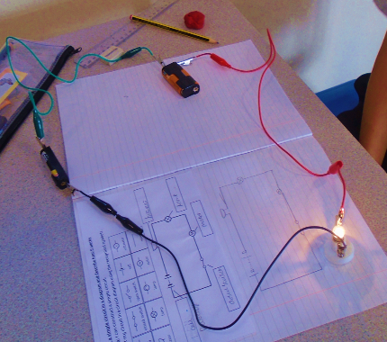

Miss Angela and Miss Yasmin would like to share what practical work **Rabbits** have done this term in science. We have been constructing circuits using a variety of electrical components and then learning how to draw circuit diagrams of them using the universal symbols.

**Lower School News from Miss Lynn:** Thank you to all those who supported The Summer Fayre at the end of Term 6, we raised £468, pupils and staff enjoyed all the activities especially throwing wet sponges in the stocks!  As we have new Pupil Council Representatives this year, they will be choosing charities to fund raise for throughout the year.

**Lower School**

**Miss Zoe’s Forest School -** this term has focussed upon the subtle transformation of trees, seed dispersal methods, humongous fungus, and vivid changes of colour in the world around us. There has been so much to explore and learn about in our incredibly diverse and stunningly beautiful woodland setting, with the added bonus of the weather also being unexpectedly warm for this time of year. As the seasons continue to change, I look forward to all the rich opportunities which

we will be presented

with to learn

important lessons,

not only about

ourselves but also

about the amazing

world around us.

**Badgers** have been reading ‘How to train your dragon’ in class and writing our own fantasy stories, using amazing vocabulary. They have also been working on their Positive Mental Attitude, why not ask them to share some of the song with you!



Miss Sadie hosted this terms **House Event**, which involved football, an obstacle course, flag matching and riddles. The event was so much fun! Thank you to the Upper School Pupils who helped with this event, these pupils are partaking in their volunteering section for their Duke of Edinburgh Award. Congratulations to Africa for winning the house event!

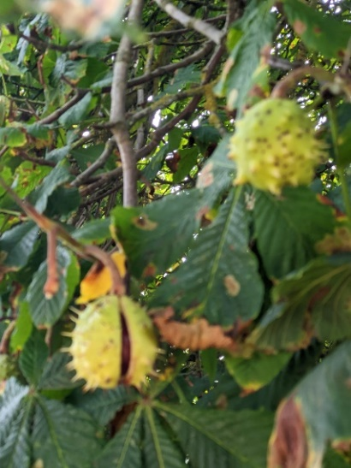

|  |  |  |
| --- | --- | --- |
| **Event** | **Pupils Involved/Location** | **Date** |
| First Day of Term | All Pupils Both Sites | Monday 6th November |
| HVS Remembrance Day | All Pupils Both Sites | Friday 10th November |
| Anti-Bullying Week | All Pupils Both Sites | Monday 13th – Friday 17th November |
| Road Safety Week | All Pupils Both Sites | Thursday 16th-Wednesday 22nd November |
| Marlowe Theatre Pantomime | 24 Pupils | Tuesday 12th December – More details to follow. |
| Christmas Jumper Day | All Pupils Both Sites | Thursday 14th December– More details to follow. |
| Last Day of Term | All Pupils Both Sites | Thursday 14th December at 12:30pm |

**Next Term Upcoming Events**

**Firm - Fair - Friendly - Fun**

**Have a great Half Term Break and we will see you back on**

**Monday 6th November 2023.**