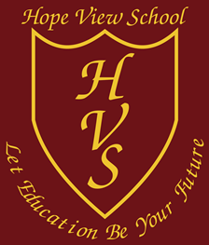
Guided Reading Map
Below are suggested texts for each half-term (spanning a whole term where appropriate), to be used within scheduled guided reading sessions. Some texts/authors which appear are the same as those being studied in English lessons in the corresponding term. This is to give pupils more time to complete whole texts in greater depth. Teachers may substitute suggested reading books for other appropriate texts of the same level, to suit pupil’s specific interests including non-fiction, but focus should remain on discussion, inference, and comprehension.
Stage 2
Term 1 | Term 2 | Term 3 | Term 4 | Term 5 | Term 6
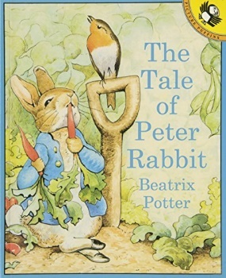  The Tale of Peter Rabbit by Beatrix Potter | 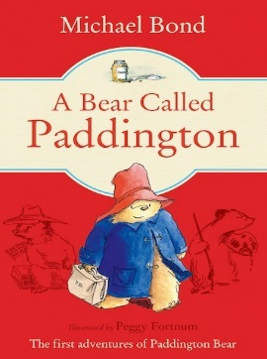  A Bear Called Paddington by Michael Bond | 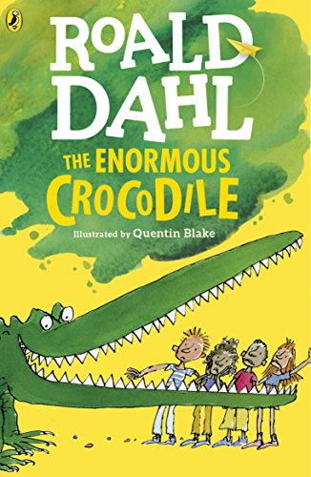  The Enormous Crocodile by Roald Dahl | 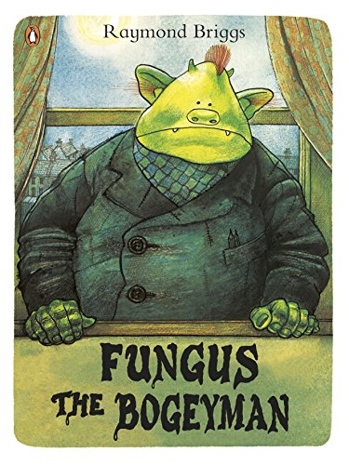  Fungus the Bogyman by Raymond Briggs | 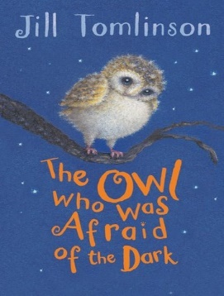  The Owl who was Afraid of the Dark by Jill Thomlinson | 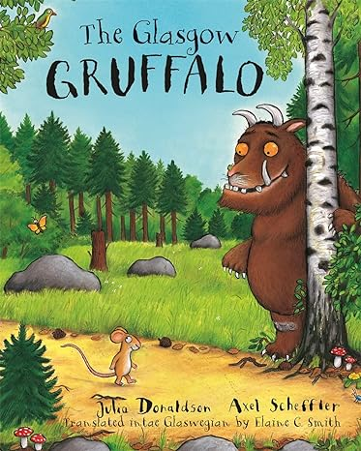  Stories by Julia Donaldson

Stage 3
Term 1 | Term 2 | Term 3 | Term 4 | Term 5 | Term 6
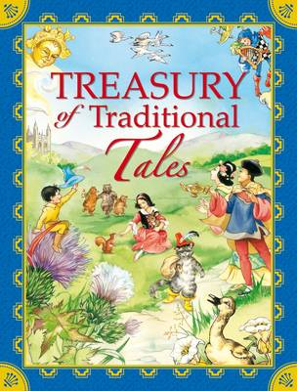  Traditional  Tales | The BFG by  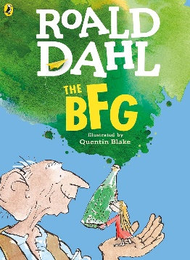  Roald Dahl | 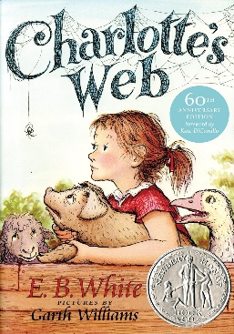  Charlotte’s Webb by E.B White | 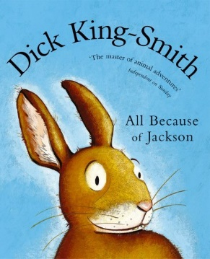  All Because of Jackson by Dick King-Smith | 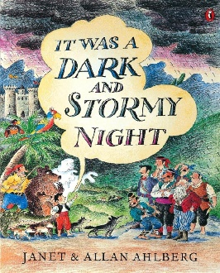  It Was a Dark and Stormy Night by Janet Ahlberg | 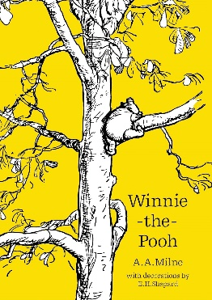  Winnie-the-pooh by A.A Milne

Stage 4
Term 1 | Term 2 | Term 3 | Term 4 | Term 5 | Term 6
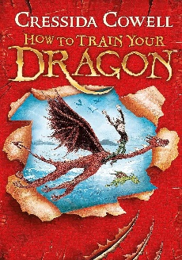  How to Train your Dragon by Cressida Cowell | 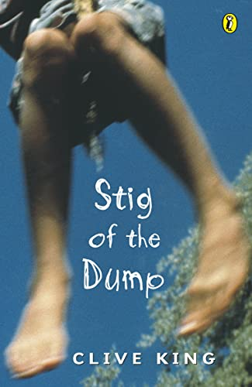  Stig of the Dump by Clive King | 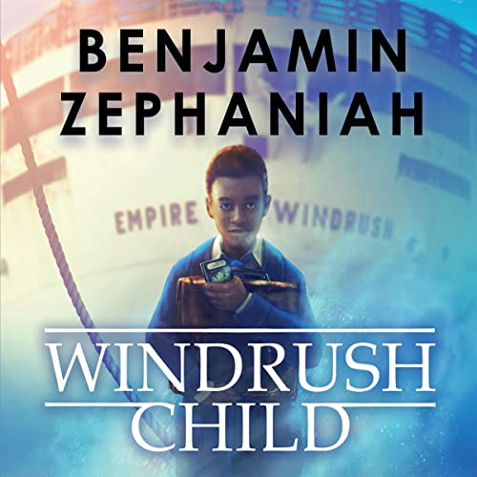  Windrush Child by Benjamin Zephaniah | 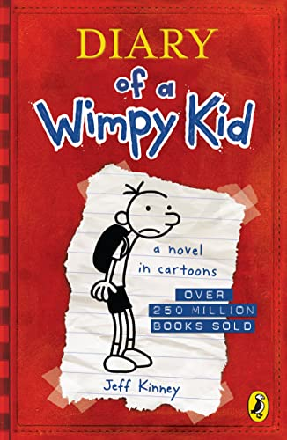  Dairy of a Wimpy Kid by Jeff Kinney | 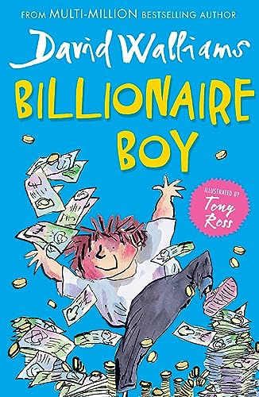  Billionaire Boy by David Walliams | 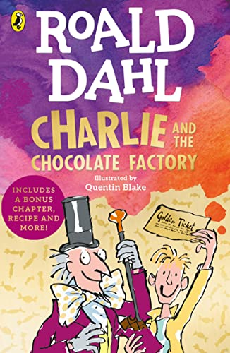  Charlie and the Chocolate Factory by Roald Dahl

Stage 5
Term 1 | Term 2 | Term 3 | Term 4 | Term 5 | Term 6
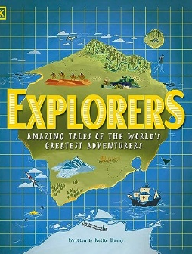  Explorers by Nellie Huang | 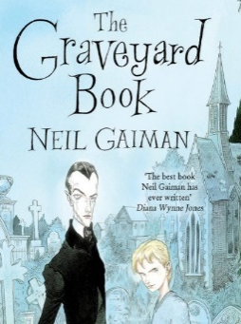  The Graveyard Book by Neil Gaiman | 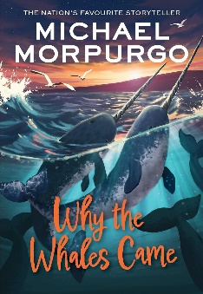  Why the Whales Came by Michael Morpurgo | 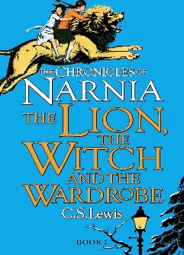  The Lion, the Witch, and the Wardrobe by C.S Lewis | 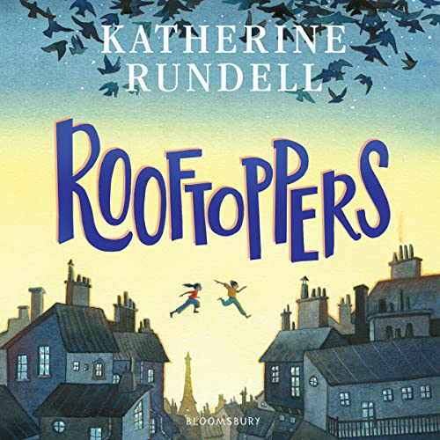  Rooftoppers by Katherine Rundell | Boy by  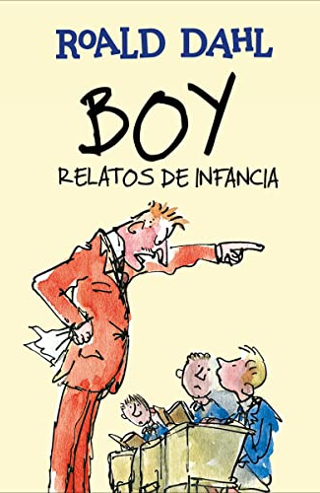  Roald Dahl

Stage 6
Term 1 | Term 2 | Term 3 | Term 4 | Term 5 | Term 6
The Explorer by Katherine Rundell  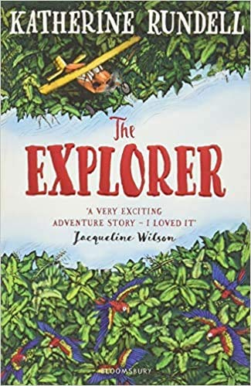 |  | 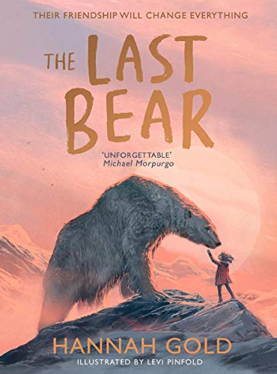  The Last Bear by Hannah Gold | 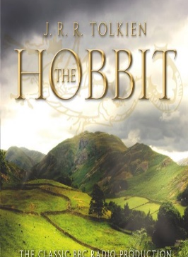  The Hobbit by JRR Tolkien | Percy Jackson and the Lightning Thief  by Rick Riordan  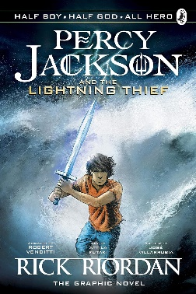

KS3 Developing- Year 1
Term 1 | Term 2 | Term 3 | Term 4 | Term 5 | Term 6
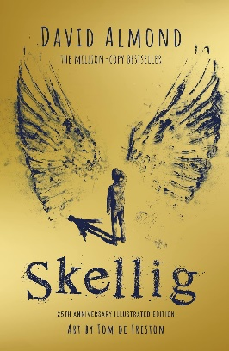  Skellig by David Almond |  | Goodnight, Mr. Tom by Michelle Magorian  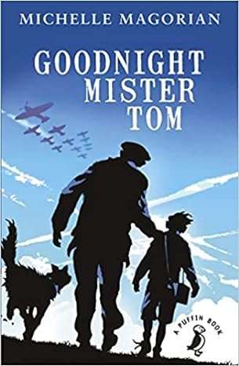 |  | Private Peaceful by Michael Morpurgo  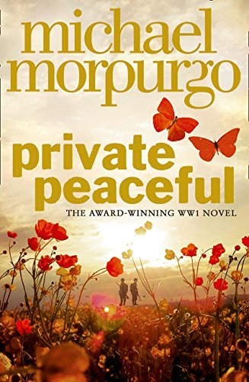

KS3 Developing- Year 2
Term 1 | Term 2 | Term 3 | Term 4 | Term 5 | Term 6
Holes by Louis Sacher  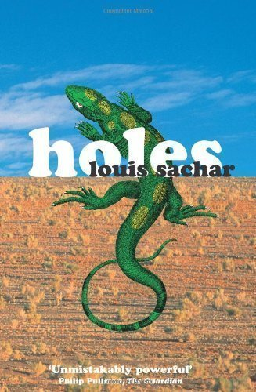 |  | Stone Cold by Robert Swindells  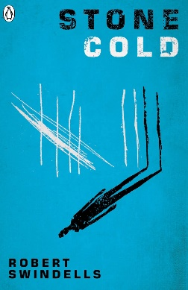 |  | The Dare by John Boyne  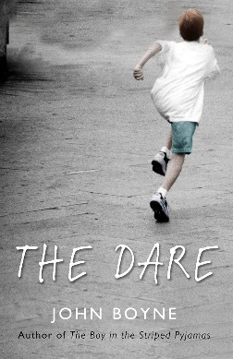

KS4- Year 1
Term 1 | Term 2 | Term 3 | Term 4 | Term 5 | Term 6
A Christmas Carol by Charles Dickens  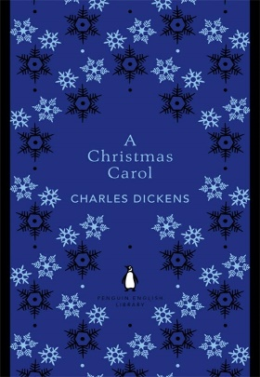 |  | Face by Benjamin Zephaniah  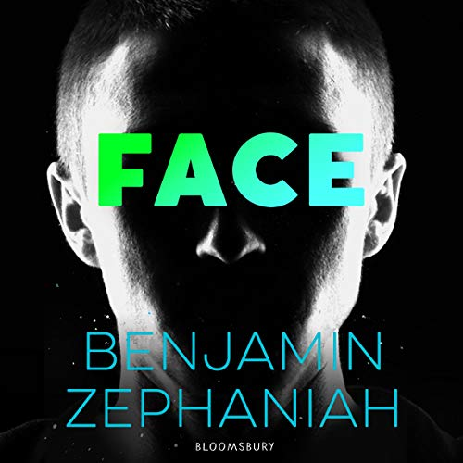 |  | 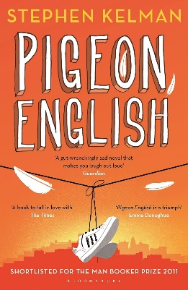  Pigeon English by Stephen Kelman

KS4- Year 2
Term 1 | Term 2 | Term 3 | Term 4 | Term 5 | Term 6
The Diary of a Young Girl by Anne Frank  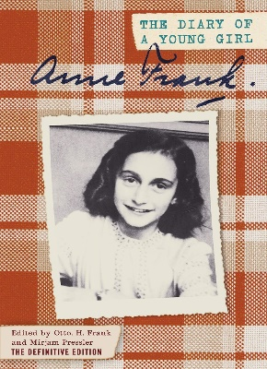 |  | 1984 by George Orwell  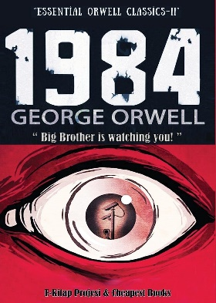 |  | The Great Gatsby by F. Scott Fitzgerald  